CRI Genetics Brings You Closer To Your Roots.
Knowing your background gives you a deeper connection to all the corners of the world that are uniquely YOURS. Know exactly where your DNA comes from with 90%+ accuracy.

Get A Detailed, Accurate Breakdown Of Your Heritage.
Our reports give you the level of detail you deserve. We cover a wide variety of ancestries, including Jewish heritage and Full Breakdowns of European, Asian, and African ancestries.

Learn More About Who You Are.
With a simple swab of your cheek, we can analyze 642,824 markers on your DNA and compare them to samples from all around the world so that we can show you your unique place in the rich history of Humanity.

Dual Ancestry Reports Will Help You Dive Deeper Into Your Family History Than Ever Before.
Your CRI Genetics Ancestry Report is really 2 ancestry reports in 1. One report shows you a breakdown of the most recent ancestries in your family history. The other goes back much farther to show you the Ancient Origins of your DNA.

About Us

CRI Genetics (Cellular Research Institute, Genetics Department) is led by Alexei Fedorov, a molecular geneticist with over 35 years of experience studying DNA. A former apprentice to Nobel Prize winning scientist Walter Gilbert, Alexei has created a patented DNA analysis algorithm using the latest breakthroughs in genetic science. His lifetime goal has been to advance Mankind’s understanding of the human genome into new frontiers.

Our mission at CRI Genetics is to unlock complex information from your DNA and present it to you in a way that’s interesting, useful, and easy to understand. There is a treasure trove of secrets hidden in your genetic code. These secrets can not only give you insight into your ancestry, but can even help you make decisions that lead to a happier, healthier life. We want to help you learn more about yourself and find ways to improve your life through genetic testing.

Not only do we provide advanced genetic reports to consumers, but we actively participate in scientific research. We believe genetic analysis is the future of medicine and we’re excited to play a role in solving complex medical problems.

How It Works

Swab your cheek—quick and painless.

Our home-based DNA collection kits ship within 24 hours of your order. They are quick, easy, and painless to use. No blood, no needles, and no pressure. We keep the process as simple as possible for you from beginning to end.

[ORDER BUTTON?]

Three Simple Steps

All From The Comfort Of Your Home.

1. Order

Begin your journey by ordering a DNA sample collection kit. Your kit will ship within 24 hours of your purchase.
ORDER NOW

2. Swab & Ship

Your kit will come with detailed instructions. Collect your DNA and mail your sample back to us in a pre-paid package.

3. Explore
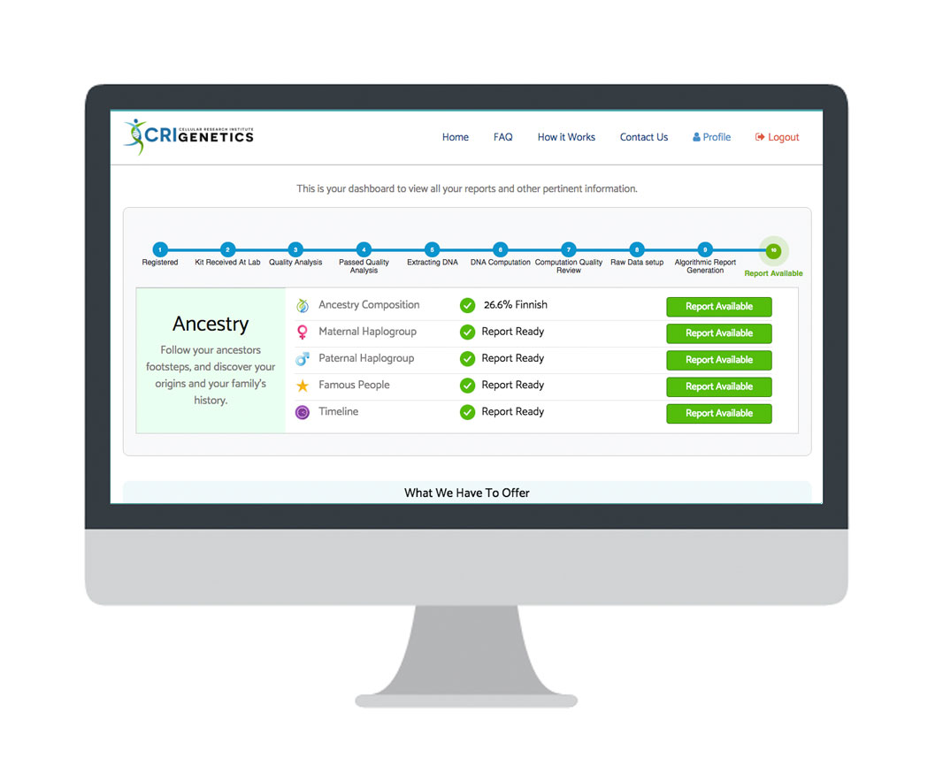
You will receive an email a few weeks later letting you know that your reports are ready. Log into your account and explore.

Useful Reports by Qualified Experts

We’re so much more than your average DNA testing service:
- All DNA samples are processed in a CLIA-certified lab in the United States.
- We use advanced genotyping chips that analyze 642,824 markers on your genome.
- We are headed by Alexei Fedorov, a renowned molecular geneticist trained by Nobel Prize winning scientists.
- Our patented DNA analysis algorithm combines genetic science with research in anthropology and sociology for an accurate look at your ancestry.
- All reports are personalized based on the latest genetic science and medical research.

We take your privacy seriously.

The moment we receive your DNA sample, we separate all personal information from it and encrypt ALL data. From that moment forward, we only know your DNA through a random serial number on your DNA collection kit. We do not share your information without your explicit consent and we take extra steps to ensure that our security is never breached.

